|  |  |  |
| --- | --- | --- |
| Name: Kaustubh Wade | ER No.: 160410116050 | Class: TYIT-1 Batch-C |

# Practical 1

## Aim: Write C# code to display the asterisk pattern as shown below:

*****

*****

*****

*****

*****

Code:

using System; namespace Practical_1

{ class Program

{ public static void Main(string[] args)

{ for (int i = 0; i < 5; i++)

{ for (int j = 0; j < 5; j++) Console.Write("*");

Console.Write("\n");

}

Console.ReadKey();

}

}

}

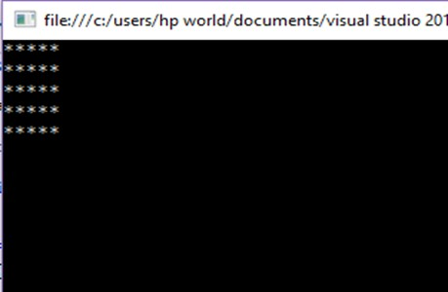Output:

|  |  |  |
| --- | --- | --- |
| Name: Kaustubh Wade | ER No.: 160410116050 | Class: TYIT-1 Batch-C |

Practical 2

Aim: Write C# code to prompt a user to input his/her name and country name and then the output will be shown as an example below:

Hello Ram from country India!

Code:

using System; namespace practical2

{ class Program

{ public static void Main(string[] args)

{ String name; String Country;

Console.WriteLine("Enter Name:"); name = Console.ReadLine();

Console.WriteLine("Enter Country Name:"); Country = Console.ReadLine();

Console.WriteLine("Hello {0} from country {1}", name, Country); Console.ReadKey();

}

}

}

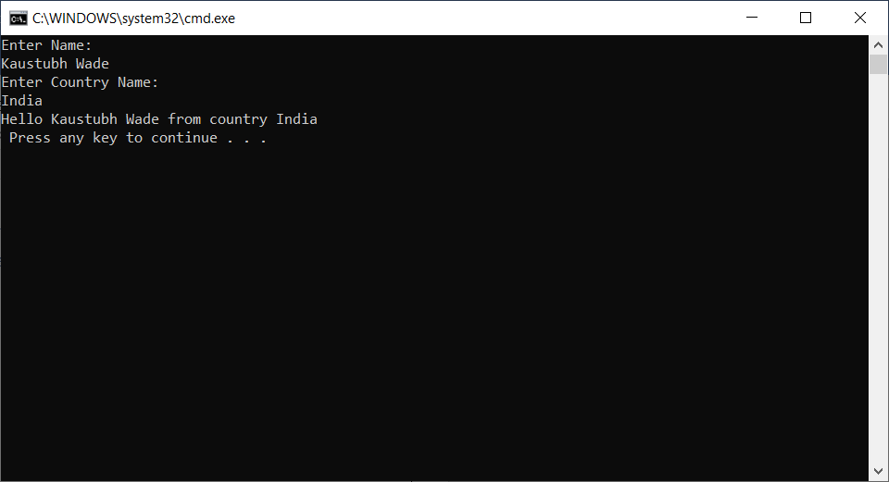Output:

|  |  |  |
| --- | --- | --- |
| Name: Kaustubh Wade | ER No.: 160410116050 | Class: TYIT-1 Batch-C |

Practical 3

Aim: Write C# code to do the following

* Convert binary to decimal
* Convert decimal to hexadecimal
* Convert decimal to binary
* Convert decimal to octal

Code:

using System; namespace practical3

{ class Program

{ public static void Main(string[] args)

{ double counter = 0; double dec = 0;

Console.WriteLine(" ****Conversation Menu**** "); Console.WriteLine(" 1. Binary to Decimal "); Console.WriteLine(" 2. Decimal to Hexadecimal "); Console.WriteLine(" 3. Decimal to Binary "); Console.WriteLine(" 4. Decimal to Octal ");

int x = Convert.ToInt32(Console.ReadLine()); int i = 1, j;

switch (x)

{ case 1: int a = Convert.ToInt32(Console.ReadLine()); int temp = a;

int modul = 0;

while (temp % 10 != temp)

{ modul = temp % 10; dec = dec + (modul *

Math.Pow(Convert.ToDouble(2), counter));

temp = temp / 10; counter++;

}

modul = temp % 10;

dec = dec + modul * Math.Pow(Convert.ToDouble(2), counter);

Console.WriteLine("Dec number is {0}", dec); break;

case 2: int decimalnumber, quotient,temp2;

char[] hexadecimalNumber = new char[100]; char temp1;

Console.WriteLine("Enter a Decimal Number :"); decimalnumber = int.Parse(Console.ReadLine()); quotient = decimalnumber;

while (quotient != 0)

{ temp2 = quotient % 16; if (temp2 < 10)

temp2 = temp2 + 48;

else

temp2 = temp2 + 55;

temp1 = Convert.ToChar(temp2); hexadecimalNumber[i++] = temp1; quotient = quotient / 16;

}

Console.Write("Equivalent Hexadecimal Number is "); for (j = i - 1; j > 0; j--)

Console.Write(hexadecimalNumber[j]);

break;

case 3: int num;

Console.WriteLine("Enter a Decimal Number : "); num = int.Parse(Console.ReadLine());

int quot;

string rem = ""; while (num>= 1)

{ quot = num / 2;

rem += (num % 2).ToString(); num = quot;

}

string bin = "";

for (i = rem.Length - 1; i >= 0; i--) bin = bin + rem[i];

Console.WriteLine("The Binary format for given number is

{0}", bin);

break;

case 4: int[] octalNumber = new int[100]; Console.WriteLine("Enter a Decimal Number :"); decimalnumber = int.Parse(Console.ReadLine()); quotient = decimalnumber;

while (quotient != 0)

{ octalNumber[i++] = quotient % 8; quotient = quotient / 8;

}

Console.Write("Equivalent Octal Number is "); for (j = i - 1; j > 0; j--)

Console.Write(octalNumber[j]);

break;

default: Console.WriteLine("Enter the choice properly"); break;

}

Console.ReadKey();

}

}

}

Output:

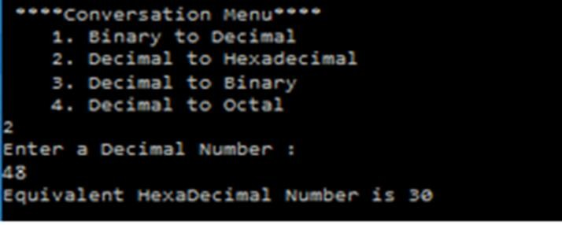*Binary to Decimal*

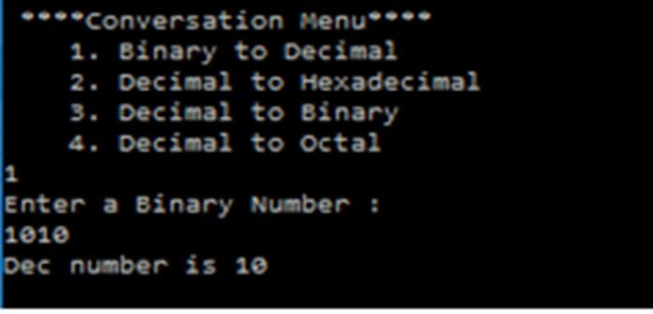*Decimal to Hexadecimal*

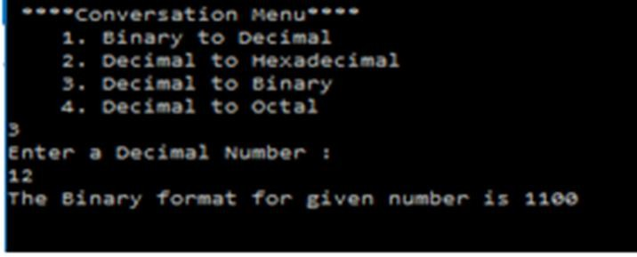*Decimal to Binary*

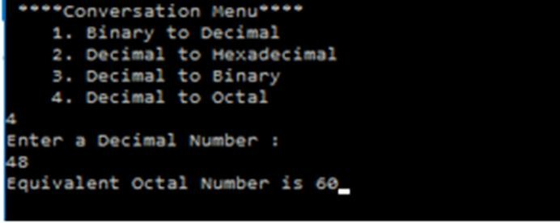*Decimal to Octal*

|  |  |  |
| --- | --- | --- |
| Name: Kaustubh Wade | ER No.: 160410116050 | Class: TYIT-1 Batch-C |

# Practical 4

## Aim : Write C# code to convert infix notation to postfix notation.

Code:

using System; usingSystem.Collections.Generic; namespace Infix

{ class Program

{ static bool convert(ref string infix, out string postfix)

{ int prio = 0; postfix = "";

Stack<Char> s1 = new Stack<char>(); for (int i = 0; i <infix.Length; i++)

{ char ch = infix[i];

if (ch == '+' || ch == '-' || ch == '*' || ch == '/')

{ if (s1.Count <= 0) s1.Push(ch);

else

{ if (s1.Peek() == '*' || s1.Peek() == '/')

prio = 1;

else

prio = 0; if (prio == 1)

{ if (ch == '+' || ch == '-')

{ postfix += s1.Pop(); i--;

}

else

{ postfix += s1.Pop();

i--;

}

}

else

{ if (ch == '+' || ch == '-')

{ postfix += s1.Pop(); s1.Push(ch);

}

else

s1.Push(ch);

}

}

}

else

postfix += ch;

}

Int len = s1.Count;

for (int j = 0; j <len; j++)

postfix += s1.Pop(); return true;

}

static void Main(string[] args)

{ string infix = ""; string postfix = ""; if (args.Length == 1)

{ infix = args[0];

convert(ref infix, out postfix);

System.Console.WriteLine("InFix :\t" + infix); System.Console.WriteLine("PostFix:\t" + postfix);

}

else

{ infix = Console.ReadLine() ; convert(ref infix, out postfix); Console.WriteLine("InFix :\t" + infix);

Console.WriteLine("PostFix :\t" + postfix); Console.WriteLine();

Console.ReadLine();

}

}

}

}

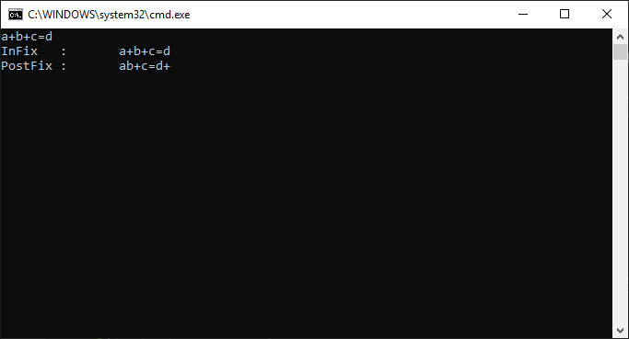Output:

|  |  |  |
| --- | --- | --- |
| Name: Kaustubh Wade | ER No.: 160410116050 | Class: TYIT-1 Batch-C |

Practical 5

Aim : Write a C# code to convert digits to words.

Code:

using System;

public class practical5

{ public static void Main()

{ int num;

int nextdigit; int numdigits;

int[] n = new int[20];

string[] digits = { "zero", "one", "two","three", "four", "five","six", "seven", "eight","nine" };

Console.WriteLine("Enter the number"); num = Convert.ToInt32(Console.ReadLine()); Console.WriteLine("Number: " + num); Console.Write("Number in words: "); nextdigit = 0;

numdigits = 0; do

{ nextdigit = num % 10; n[numdigits] = nextdigit; numdigits++;

num = num / 10;

}while (num> 0); numdigits--;

for (; numdigits>= 0; numdigits--) Console.Write(digits[n[numdigits]] + " ");

Console.WriteLine();

Console.ReadLine();

}

}

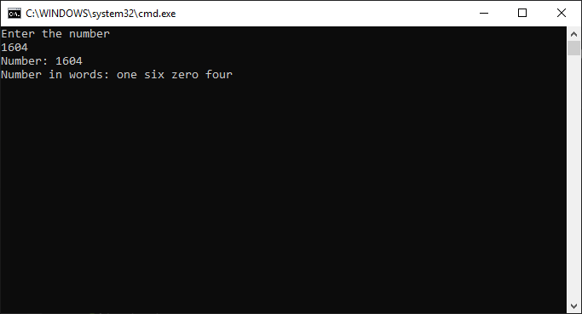Output:

|  |  |  |
| --- | --- | --- |
| Name: Kaustubh Wade | ER No.: 160410116050 | Class: TYIT-1 Batch-C |

Practical 6

Aim : Write a C# code to Convert following currency conversion. Rupees to dollar, frank, euro. (windows app)

Code:

using System; usingSystem.Collections.Generic; usingSystem.ComponentModel; usingSystem.Data; usingSystem.Drawing; usingSystem.Linq; usingSystem.Text; usingSystem.Threading.Tasks; usingSystem.Windows.Forms; namespace prractical6

{ public partial class Form1 : Form

{ public Form1()

{ InitializeComponent(); }

private void button1_Click(object sender, EventArgs e)

{ double rupee, dollar, frenchfranc,euro; rupee = double.Parse(textBox1.Text); dollar = rupee / 60;

textBox2.Text = dollar.ToString(); frenchfranc = rupee / 10.72; textBox3.Text = frenchfranc.ToString(); euro = rupee / 70.36;

textBox4.Text = euro.ToString();

}

}

}

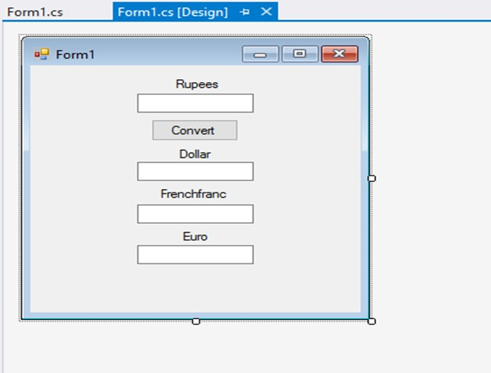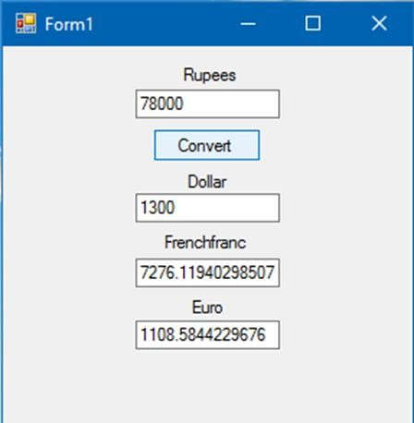Output:

|  |  |  |
| --- | --- | --- |
| Name: Kaustubh Wade | ER No.: 160410116050 | Class: TYIT-1 Batch-C |

Practical 7

Aim : Write a C# code to Perform Celsius to Fahrenheit Conversion and Fahrenheit to Celsius conversion. (Windows app)

Code:

using System; usingSystem.Collections.Generic; usingSystem.ComponentModel; usingSystem.Data; usingSystem.Drawing; usingSystem.Linq; usingSystem.Text; usingSystem.Threading.Tasks; usingSystem.Windows.Forms; namespace pr7

{ publicpartialclassForm1 : Form

{ public Form1()

{ InitializeComponent(); }

privatevoid label2_Click(object sender, EventArgs e)

{ }

privatevoid button1_Click(object sender, EventArgs e)

{ Try

{ if (textBox1.Text == ""&& textBox2.Text == "") MessageBox.Show("Enter Input for 1 box");

if ((!(textBox1.Text == "")) && (!(textBox2.Text == ""))) MessageBox.Show("Enter data for only 1 box");

if (textBox1.Text == "")

textBox1.Text = (((Convert.ToDouble(textBox2.Text) - 32) *

5) /.ToString();

if (textBox2.Text == "")

textBox2.Text = ((Convert.ToDouble(textBox1.Text) * 9) / 5 +

.ToString();

}

catch { }

}

}

}

Output:

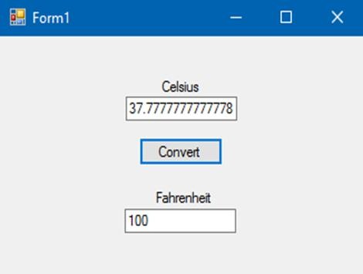*Celsius to Fahrenheit:*

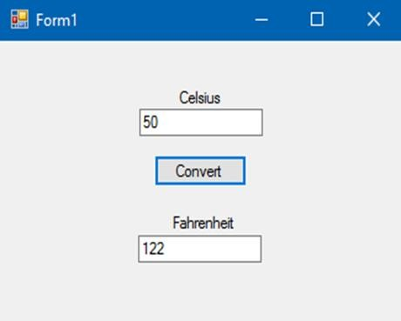*Fahrenheit to Celsius:*

|  |  |  |
| --- | --- | --- |
| Name: Kaustubh Wade | ER No.: 160410116050 | Class: TYIT-1 Batch-C |

# Practical 8

## Aim : Write a program to increase and decrease font size programmatically. (Windows app)

Code:

using System; usingSystem.Collections.Generic; usingSystem.ComponentModel; usingSystem.Data; usingSystem.Drawing; usingSystem.Linq; usingSystem.Text; usingSystem.Threading.Tasks; usingSystem.Windows.Forms; namespace practical8

{ publicpartialclassForm1 : Form

{ public Form1()

{ InitializeComponent(); }

privatevoid button1_Click(object sender, EventArgs e)

{ label1.Font = newFont(label1.Font.FontFamily, 6); } privatevoid button2_Click(object sender, EventArgs e)

{ label1.Font = newFont(label1.Font.FontFamily, 30); } privatevoid Form1_Load(object sender, EventArgs e)

{ }

}

}

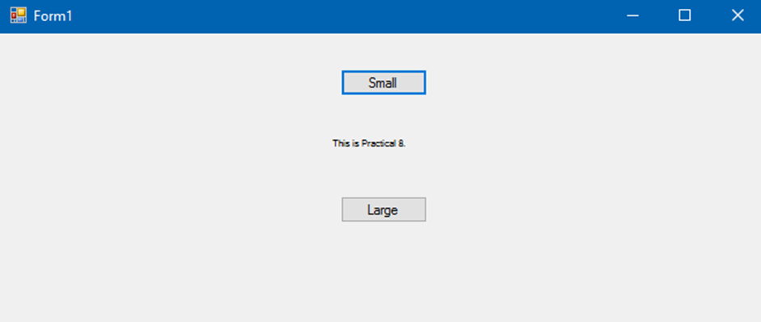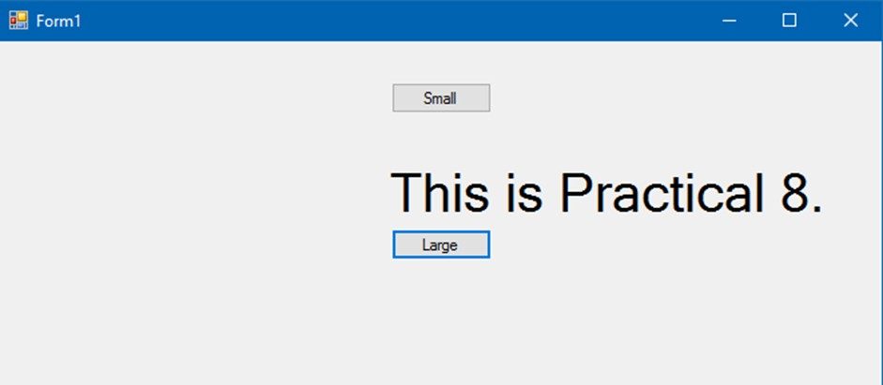Output:

|  |  |  |
| --- | --- | --- |
| Name: Kaustubh Wade | ER No.: 160410116050 | Class: TYIT-1 Batch-C |

Practical 9

Aim : Write a program to check whether empty query string is entered in Asp .net.

Code:

*Webform1.aspx:*

<%@PageLanguage="C#"AutoEventWireup="true"CodeBehind="WebForm1.aspx.cs"Inherits="pra9. WebForm1"%>

<!DOCTYPEhtml>

<htmlxmlns[="http://www.w3.org/1999/xhtml">](http://www.w3.org/1999/xhtml)

<headrunat="server">

<title></title>

</head>

<body>

<form id="form1"runat="server">

<div>

Enter Your Name :

<asp:TextBoxID="textname"runat="server"></asp:TextBox>

<br/>

<br/>

<asp:ButtonID="button1"runat="server"OnClick="button1_Click"Text="Submit"/>

</div>

</form>

</body>

</html>

*Webform1.aspx.cs:*

using System; usingSystem.Collections.Generic; usingSystem.Linq; usingSystem.Web; usingSystem.Web.UI;

usingSystem.Web.UI.WebControls; namespace pra9

{ publicpartialclassWebForm1 : System.Web.UI.Page

{ protectedvoidPage_Load(object sender, EventArgs e)

{ }

protectedvoid button1_Click(object sender, EventArgs e)

{ if (textname.Text.Length == 0)

Response.Write("Please Enter Your Name");

}

}

}

Output:

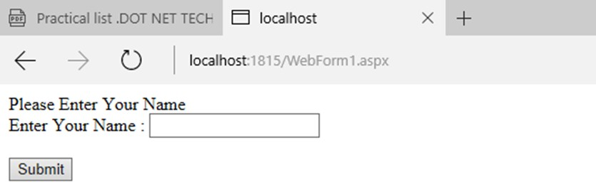

|  |  |  |
| --- | --- | --- |
| Name: Kaustubh Wade | ER No.: 160410116050 | Class: TYIT-1 Batch-C |

Practical 10

Aim : Write a program to change colour of Label text control programmatically in Asp

.Net

Code:

using System; usingSystem.Collections.Generic; usingSystem.Linq; usingSystem.Web; usingSystem.Web.UI; usingSystem.Web.UI.WebControls; namespace practical10

{ publicpartialclassWebForm1 : System.Web.UI.Page

{ protectedvoidPage_Load(object sender, EventArgs e)

{ }

protectedvoid Button2_Click(object sender, EventArgs e)

{ Label1.ForeColor = System.Drawing.Color.Yellow; } protectedvoid Button1_Click(object sender, EventArgs e)

{ Label1.ForeColor = System.Drawing.Color.Green; } protectedvoid Button3_Click(object sender, EventArgs e)

{ Label1.ForeColor = System.Drawing.Color.Blue; }

}

}

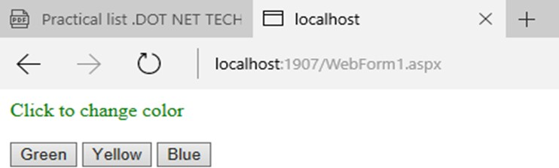Output:

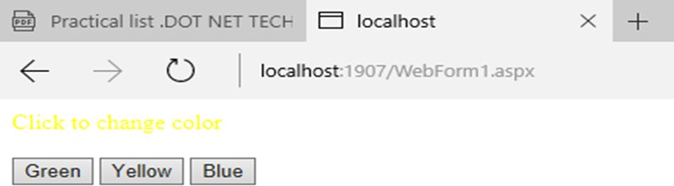

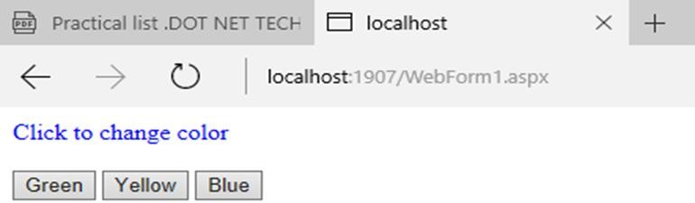

|  |  |  |
| --- | --- | --- |
| Name: Kaustubh Wade | ER No.: 160410116050 | Class: TYIT-1 Batch-C |

Practical 11

Aim : Write a program to Enable-Disable Textbox and change width of TextBox programmatically in Asp .Net

Code:

*WebForm1.aspx:*

<%@PageLanguage="C#"AutoEventWireup="true"CodeBehind="WebForm1.aspx.cs"Inherits="practi cal11.WebForm1"%>

<!DOCTYPEhtml>

<htmlxmlns=["http://www.w3.org/1999/xhtml">](http://www.w3.org/1999/xhtml)

<headrunat="server">

<title></title>

</head>

<body>

<formid="form1"runat="server">

<div>

<asp:ButtonID="Button1"runat="server"Text="Enable"OnClick="Button1_Click"/>

<asp:ButtonID="Button2"runat="server"Text="Disable"OnClick="Button2_Click"/>

<br/> <br/>

<asp:TextBoxID="TextBox1"runat="server"></asp:TextBox>

<br/> <br/>

<asp:LabelID="Label1"runat="server"Text="Width :"></asp:Label>

<asp:TextBoxID="TextBox2"runat="server"></asp:TextBox>

<br/>

<asp:ButtonID="Button3"runat="server"OnClick="Button3_Click"Text="Change Width"/>

</div>

</form>

</body>

</html>

*WebForm1.aspx.cs:*

using System; usingSystem.Collections.Generic; usingSystem.Linq; usingSystem.Web; usingSystem.Web.UI; usingSystem.Web.UI.WebControls; namespace practical11

{ publicpartialclassWebForm1 : System.Web.UI.Page

{ protectedvoidPage_Load(object sender, EventArgs e)

{ }

protectedvoid Button1_Click(object sender, EventArgs e)

{ TextBox1.Enabled = true; }

protectedvoid Button2_Click(object sender, EventArgs e)

{ TextBox1.Enabled = false; }

protectedvoid Button3_Click(object sender, EventArgs e)

{ TextBox1.Width = Convert.ToInt16(TextBox2.Text); }

}

}

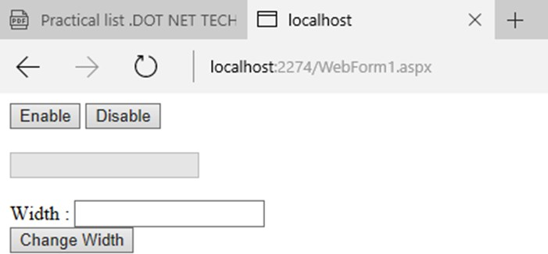Output:

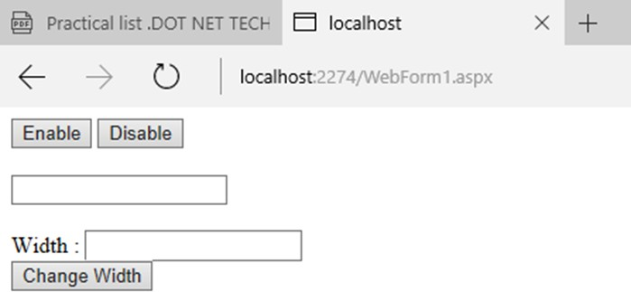

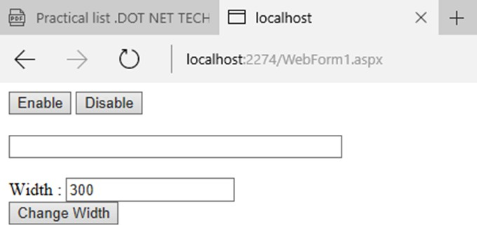

|  |  |  |
| --- | --- | --- |
| Name: Kaustubh Wade | ER No.: 160410116050 | Class: TYIT-1 Batch-C |

Practical 12

Aim : Write ASP.Net program to Store Objects in Session State and Storing Session State in SQL Server.

Code:

*Products.aspx:*

<%@PageLanguage="C#"AutoEventWireup="true"CodeBehind="Products.aspx.cs"Inherits="pra12.Pr oducts"%>

<!DOCTYPEhtml>

<htmlxmlns=["http://www.w3.org/1999/xhtml">](http://www.w3.org/1999/xhtml)

<headrunat="server">

<title></title>

</head>

<body>

<formid="form1"runat="server">

<asp:GridViewID="GridView1"runat="server"AutoGenerateColumns="False"DataKeyNames= "ProductName"DataSourceID="SqlDataSource1"OnSelectedIndexChanged="GridView1_SelectedInd exChanged">

<Columns>

<asp:BoundFieldDataField="ProductName"HeaderText="ProductName"ReadOnly="True"SortExpress ion="ProductName"/>

<asp:BoundFieldDataField="UnitPrice"HeaderText="UnitPrice"SortExpression="UnitPrice"/>

<asp:CommandFieldSelectText="Add to Cart"ShowHeader="True"ShowSelectButton="True"/>

</Columns>

</asp:GridView>

<asp:HyperLinkID="HyperLink1"runat="server"NavigateUrl="~/Cart.aspx"Font- Bold="True"Font-Size="Large">I'm Done, show products</asp:HyperLink>

<asp:SqlDataSourceID="SqlDataSource1"runat="server"ConnectionString="<%$ ConnectionStrings:ConnectionString%>"SelectCommand="SELECT * FROM [products]"></asp:SqlDataSource>

<div>

</div>

</form>

</body>

</html>

*Products.aspx.cs:*

using System; usingSystem.Collections.Generic; usingSystem.Linq; usingSystem.Web; usingSystem.Web.UI; usingSystem.Web.UI.WebControls; usingSystem.Data; usingSystem.Data.SqlClient; namespace pra12

{ publicpartialclassProducts : System.Web.UI.Page

{ protectedvoidPage_Load(object sender, EventArgs e)

{ }

protectedvoid GridView1_SelectedIndexChanged(object sender, EventArgs e)

{ DataSet ds = null;

if (Session["Cart"] == null)

{ ds = newDataSet(); DataTabledt = newDataTable();

dt.Columns.Add(newDataColumn("Productname"));

dt.Columns.Add(newDataColumn("Quantity", typeof(System.Int32)));

ds.Tables.Add(dt); Session["Cart"] = ds;

}

else

{ ds = (DataSet)Session["Cart"]; }

DataRow row = ds.Tables[0].NewRow(); row["productname"] =

GridView1.Rows[GridView1.SelectedIndex].Cells[0].Text; row["quantity"] = 1; ds.Tables[0].Rows.Add(row);

}

}

}

*Cart.aspx:*

<%@PageLanguage="C#"AutoEventWireup="true"CodeBehind="Cart.aspx.cs"Inherits="pra12.Cart"

%>

<!DOCTYPEhtml>

<htmlxmlns=["http://www.w3.org/1999/xhtml">](http://www.w3.org/1999/xhtml)

<headrunat="server">

<title></title>

</head>

<body>

<formid="form1"runat="server">

<asp:GridViewID="GridView1"runat="server"OnSelectedIndexChanged="GridView1_Selecte dIndexChanged1"Width="339px">

<Columns>

<asp:BoundFieldDataField="productname"HeaderText="ProductName"/>

<asp:BoundFieldDataField="quantity"HeaderText="Quantity"/>

</Columns>

</asp:GridView>

<div>

</div>

</form>

</body>

</html>

*Cart.aspx.cs:*

using System; usingSystem.Collections.Generic; usingSystem.Linq; usingSystem.Web; usingSystem.Web.UI; usingSystem.Web.UI.WebControls; usingSystem.Data; usingSystem.Data.SqlClient; namespace pra12

{ publicpartialclassCart : System.Web.UI.Page

{ protectedvoidPage_Load(object sender, EventArgs e)

{ GridView1.DataSource = (DataSet)Session["Cart"]; GridView1.DataBind();

}

protectedvoid GridView1_SelectedIndexChanged(object sender, EventArgs e)

{ }

}

}

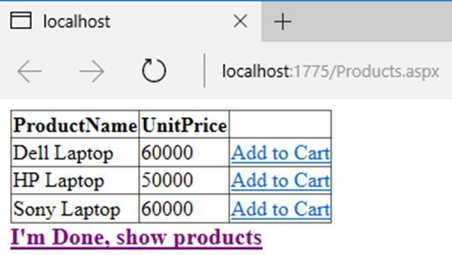Output:

